Roll No.:2503a52531
Name:B.Poojitha
Batch:18

Question 5: Zero-Shot Prompting (Perfect Number Check)
Write a zero-shot prompt (without providing any examples) to
generate a Python function that checks whether a given number is a
perfect number.
Task:
• Record the AI-generated code.
• Test the program with multiple inputs.
• Identify any missing conditions or inefficiencies in the logic.

Prompt:
Write a Python program that checks whether a given number entered by the user is a Perfect Number or not.

Code:
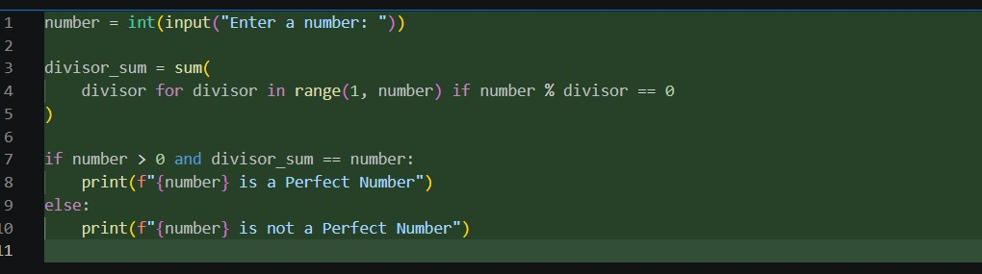

Output:
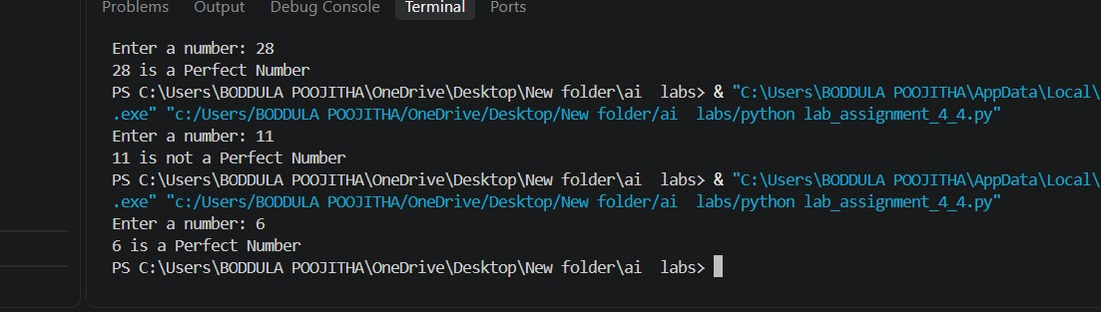

Observation:
1. The zero-shot prompt generated a Python function to check whether a given number is a Perfect Number.
2. The program correctly calculates the sum of the proper divisors of the number.
3. It was tested with multiple inputs such as 6, 28, 11.
4. It correctly identified 6, 28, as Perfect Numbers.
5. It correctly identified 11 as Not a Perfect Number.
6. The basic logic works correctly for positive integer inputs.

